**SMT Assignment-7 Report**

1. I have found the below problems in the code.

For testing the CheckLines method I have created the following test case

@Test

**public** **void** testCheckLines() {

**int** i = boardPanel.checkLines();

*assertEquals*(0,i);

}

In the above testcase I am testing whether the checkLines method is returning completedLines correctly after checking each row and if each row is filled with the tiles then the rest of the board should come down.

Here I am creating a variable ‘i’ and assigning it to the value returned by boardPanel.checkLines(); method.

By using assertEquals I am comparing the Expected value and Actual value returned by boardPanel.checkLines(); method.

When I am giving the expected value as 0, I am getting the actual value as 22 instead of 0 and the test case if failing because of problem in the code.

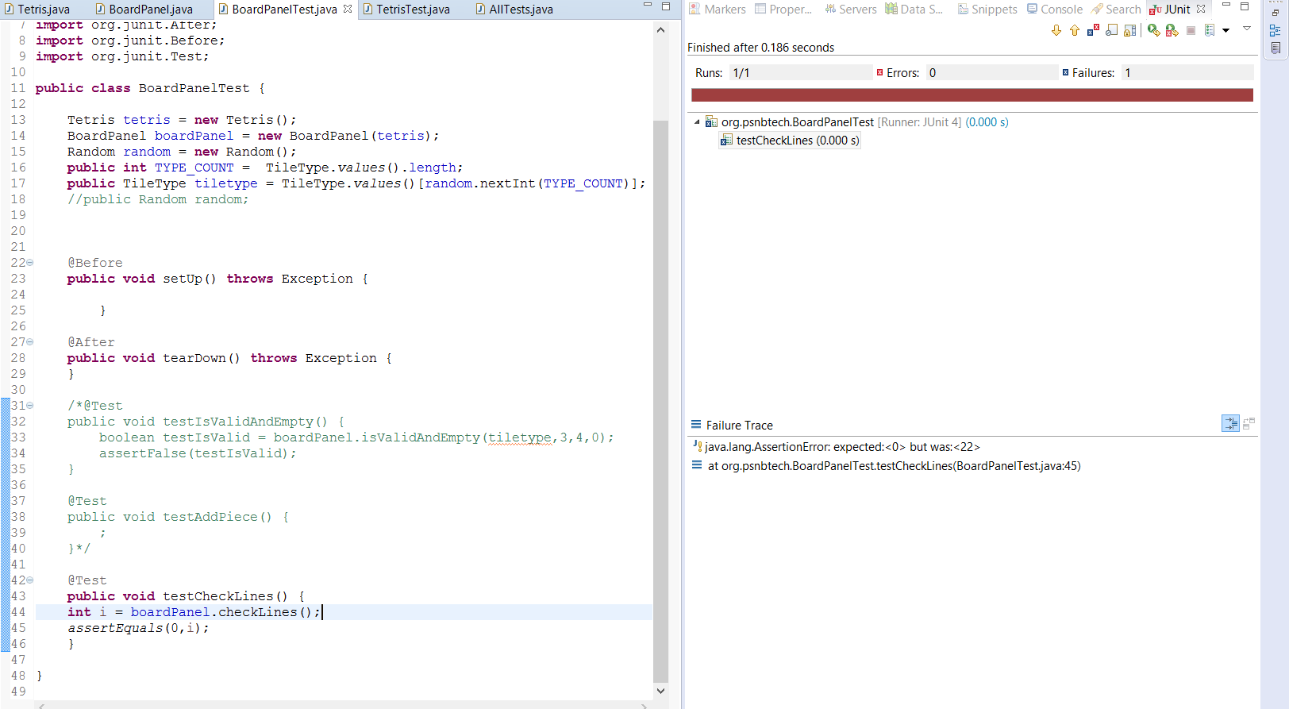

1. Below is the test case I have created for updateGame method
2. @Test
3. **public** **void** testUpdateGame() {
4. **int** i = tetris.getScore();
5. *assertEquals*(0,i);
7. }

In this test case I have created a variable ‘i’ and assigned it to the value returned by tetris.getScore(); method. Here I am comparing the expected score and actual score before starting the game. Here my expected value and the actual value I got as 0. By using the above test case I have verified getScore() method. My testcase passed when both expected and actual value are the same.

Here my logic is simply comparing the expected value and the actual value by running the getScore() method before starting the Tetris game.

3.

